**Project Design Phase-II**

**Data Flow Diagram & User Stories**

| Date | 26-06-2025 |
| --- | --- |
| Team ID | LTVIP2025TMID58389 |
| Project Name | Order on the go |
| Maximum Marks | 4 Marks |

**Data Flow Diagrams:**

A Data Flow Diagram (DFD) illustrates how data flows within the SB Foods platform. It visually represents the interactions between users (customers, restaurant owners, and admins) and the system, showing how information is processed, transferred between components, and stored in the database.



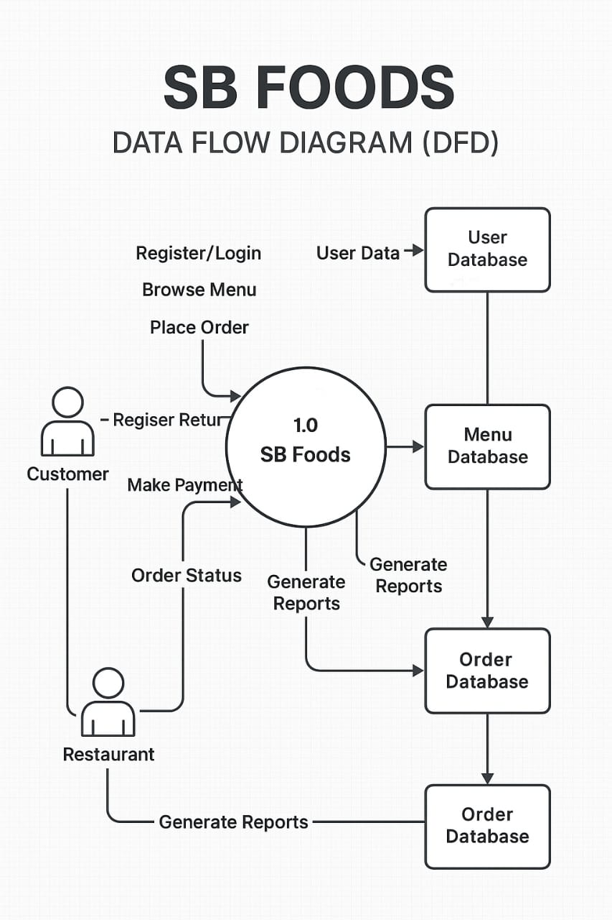

**User Stories**

**User Story Table – Order on the go**

| **User Type** | **Functional Requirement (Epic)** | **User Story / Task** | **Acceptance Criteria** | **Priority** | **Release** |
| --- | --- | --- | --- | --- | --- |
| | **Customer** | | --- |  |  | | --- | | | Dish Discovery | | --- | | As a customer, I can browse dishes by category, restaurant, or popularity. | Dishes are displayed based on selected filter or search. | High | Sprint-1 |
|  | Order Placement | As a customer, I can place an order by selecting dishes and providing my details. | | Order gets confirmed and a  summary is displayed. | | --- |  |  | | --- | | High | Sprint-1 |
| | **Restaurant**  **Owner** | | --- |  |  | | --- | | | Menu Management | | --- |  |  | | --- | | | | As a restaurant owner, I can add, edit, or remove dishes from the menu. | | --- |  |  | | --- | | | --- | --- | --- | | | Changes reflect immediately in customer view. | | --- |  |  | | --- | | High | Sprint-1 |
| **Restaurant Owner** | Order Management | As a restaurant owner, I can accept and update the status of incoming orders. | Order status changes are tracked and visible to customers. | High | Sprint-2 |
| **Admin** | User Management | As an admin, I can view and manage customer and restaurant accounts. | Admin can deactivate or modify user access. | High | Sprint-2 |
| **Admin** | Report Moderation | As an admin, I can review user reports and take necessary actions. | Actions taken are recorded and reports are closed. | Medium | Sprint-2 |
| **Delivery Agent** | Delivery Tracking   |  | | --- | | As a delivery agent, I can view assigned orders and update delivery status. | Delivery updates are synced with customer and restaurant view. | Medium | Sprint-2 |